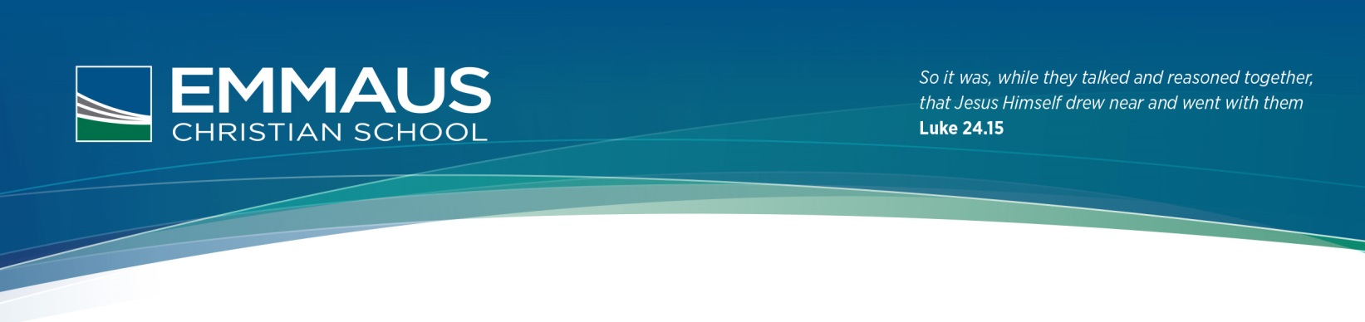  
  
  
  
 **iPad User Agreement 2016**

## The student will:

* Bring the iPad to school each day **fully charged**.
* Ensure that **all apps are closed** at the beginning of the day and be prepared for a spot check.
* Use the iPad for educational purposes and **not access anything that their teacher has not requested** such as games, social media or websites. ***(There will be spot checks in all classes where the student may be asked to ‘double click’ the home button to show which apps they have open***)
* Ensure that the iPad is in a sturdy case that is free from any form of graffiti, stickers or markings other than the student’s name.
* **Not access social media** applications such as facetime, messaging, Facebook, Instagram etc. during school hours. ***\*Edmodo can be accessed if required by your teacher\****
* Bring the iPad to all classes and ensure that it is stored safely in their lockers at Recess, Lunch and during Sport.
* 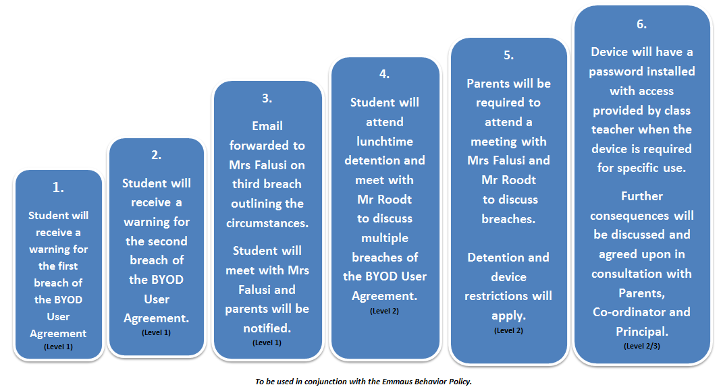**Back up all documents** and information on their iPad. Loss of work is not an acceptable excuse for late assignments or homework.
* Be aware that all material on the iPad is subject to review by School Staff if requested.
* Adhere to Emmaus’s Student Network and Technology Agreement.
* Accept consequences outlined if they breach the use of the iPad.

**Consequences for Breach of the Emmaus BYOD User Agreement 2016.**

✂  
*Students and parents/carers must carefully read this agreement prior to signing it. Any questions should be forwarded to Mrs Toni Falusi* [*toni@emmaus.act.edu.au*](mailto:toni@emmaus.act.edu.au) *and clarification obtained before the agreement is signed.*

|  |  |  |
| --- | --- | --- |
| iPad User Agreement | Please initial | |
| I have read the iPad User Agreement and I acknowledge that I understand and agree to the iPad User Agreement guidelines, including consequences for any breach. |  |  |
| The iPad is covered by the parent/carers insurance in case of damage of loss. |  |  |
| I understand that failure to comply with the iPad User Agreement will result in the consequences outlined in the document. |  |  |
| I have read the Student Network and Technology Agreement 2016 and have discussed it with my child. |  |  |

|  |  |
| --- | --- |
| iPad Serial Number |  |

Student’s name (print)______________________________ Year ________ Homeroom Teacher: _____________

_________________________________________ _________________________________________ Student’s Signature Parent’s Signature (Mother/Father/Other)

Date: Date:

**PLEASE SIGN AND RETURN TO YOUR HOMEROOM TEACHER**